Kakute HAT Expansion Board V2.0

The Kakute HAT is an expansion board for the Raspberry Pi, which allows a KakuteF4 (non-AIO) to be interfaced (send telemetry to the Pi). Additionally, it contains breakout ports for RC In, GPS, Servo Out and others.

It contains a 5V, 2.5A power supply for the Raspberry Pi and has power switches for both the Kakute and Pi.

# Requirements

* Input power: 7-18V
* Requires a Holybro Kakute F4 V2 (or later) non-AIO
* Requires a Raspberry Pi 2 or later

# Kakute Ports

* RC In, 3-pin
* Servo Out x4, 3-pin
* GPS, JSH-GH (Dronecode standard)

# Layout

Raspberry Pi interface

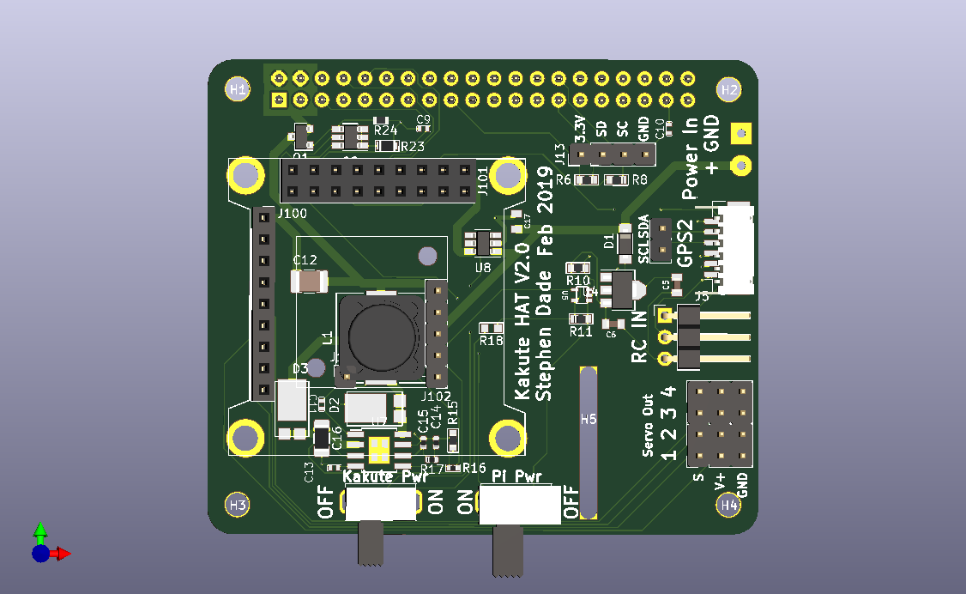

Kakute Interface

Kakute Power Switch (Left=OFF, Right=ON)

Pi Power Switch (Left=OFF, Right=ON)

Camera cable slot

Servo (motor) out 1-4

RC In

GPS Port

Power In (7-18V)

# Setting Up

## Hardware

1. Solder on the appropriate power connectors to the “Power In” port
2. Place the board on the Raspberry Pi, using the 40-pin connector. If the Pi’s camera port is being used, ensure the thread the camera cable though the slot
3. Add in screws and standoffs to secure the Kakute Hat board to the Raspberry Pi
4. Place the Kakute in the 9 and 18-pin connector
   1. If the I2C ports on the Kakute are being used, they should be soldered with cable and connected to the SCL and SDA ports on the board.
5. Connect up the GPS, RC In and Servo connectors as required.

## Software

1. For the power switch to work, the following lines need to be added to /boot/config.txt:

dtoverlay=gpio-shutdown

dtoverlay=gpio-poweroff

1. For the Kakute to send/receive telemetry to the Pi’s UART, use the “sudo raspi-config” command then go to Interfacing Options -> Serial -> No login shell -> Enable serial port.
2. On the Kakute, the following parameters need to be set for the telemetry port to the Pi:

SERIAL1_PROTOCOL = 2

SERIAL1_BAUD=921

1. On the Pi, the port /dev/ttyS0 at a baud rate of 921600 will now output MAVLink telemetry.

# Further ideas

* The “APSync” software (<http://ardupilot.org/dev/docs/apsync-intro.html>) is a ready-to-use software suite for managing the Kakute’s telemetry and gives a basic web-based ground station
* The Camera on the Pi can be streamed over Wifi (or over a 3G USB dongle) to give an “FPV” stream from the vehicle it’s on
* The Pi could be used for real-time image processing to control a vehicle to follow/avoid specific objects

# Support

I can be emailed at [stephen_dade@hotmail.com](mailto:stephen_dade@hotmail.com) for any support.